Project Report Template

Recruiting Assistant for HR Managers

1. INTRODUCTION
   1. **Overview**

**A human resources assistant is a certified professional who handles the daily administrative and HR duties of an organization. They assist HR managers with recruitment,record maintenance , payroll processing ,provide clerical support to all employees. HR assistants provide office support to HR directors and the entire human resources department by helping with tasks like storing staff files,writing letters and conducting other administrative responsibilities.**

* 1. **Purpose**

**The overall purpose of human resources is to ensure that the organization is able to achieve success through people. HR professionals manage the human capital of an organization and focus on implementing policies and processes.**

1. Problem Definition & Design Thinking
   1. **Empathy Map**

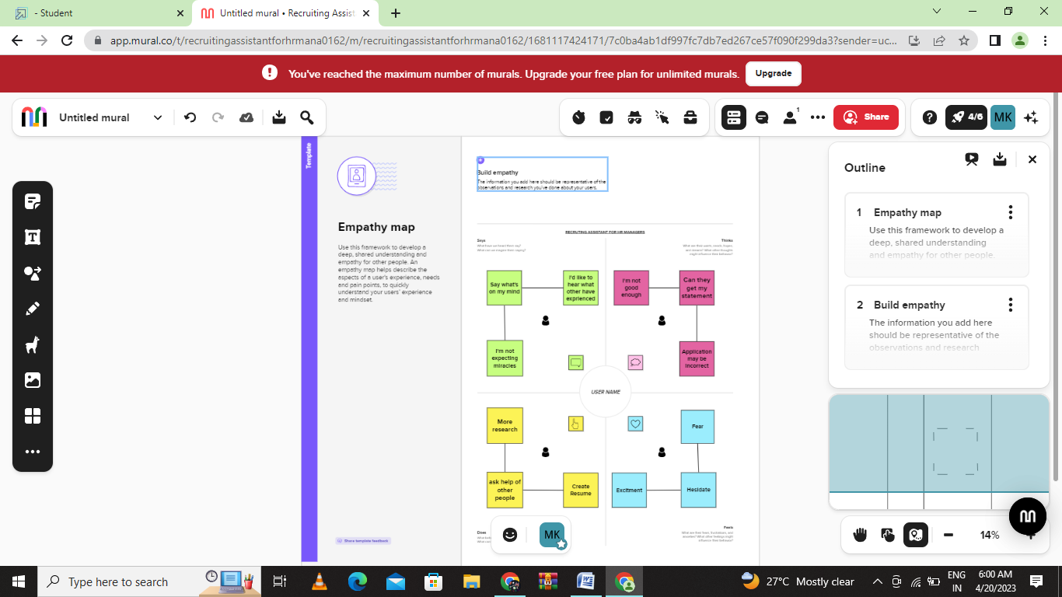

**2.2 Ideation & Brainstroming Map**

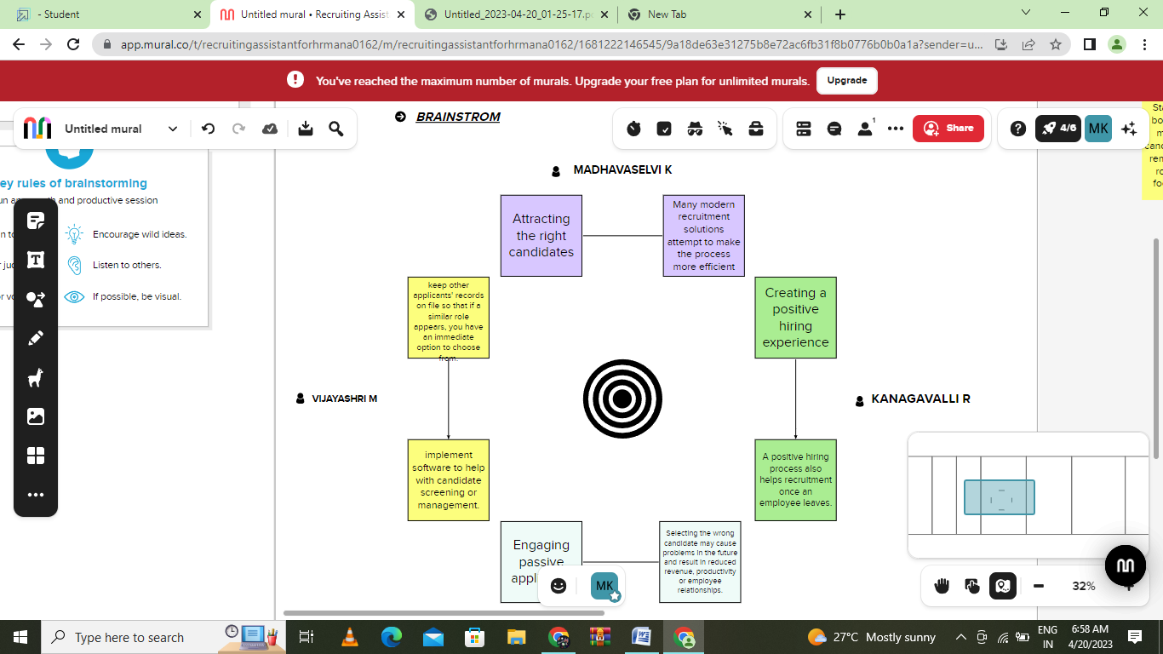

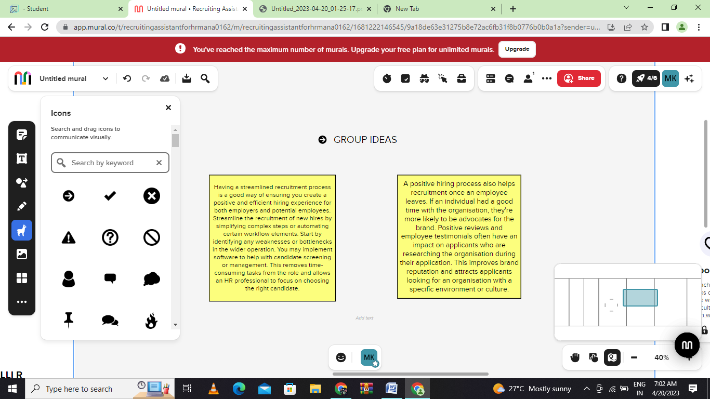

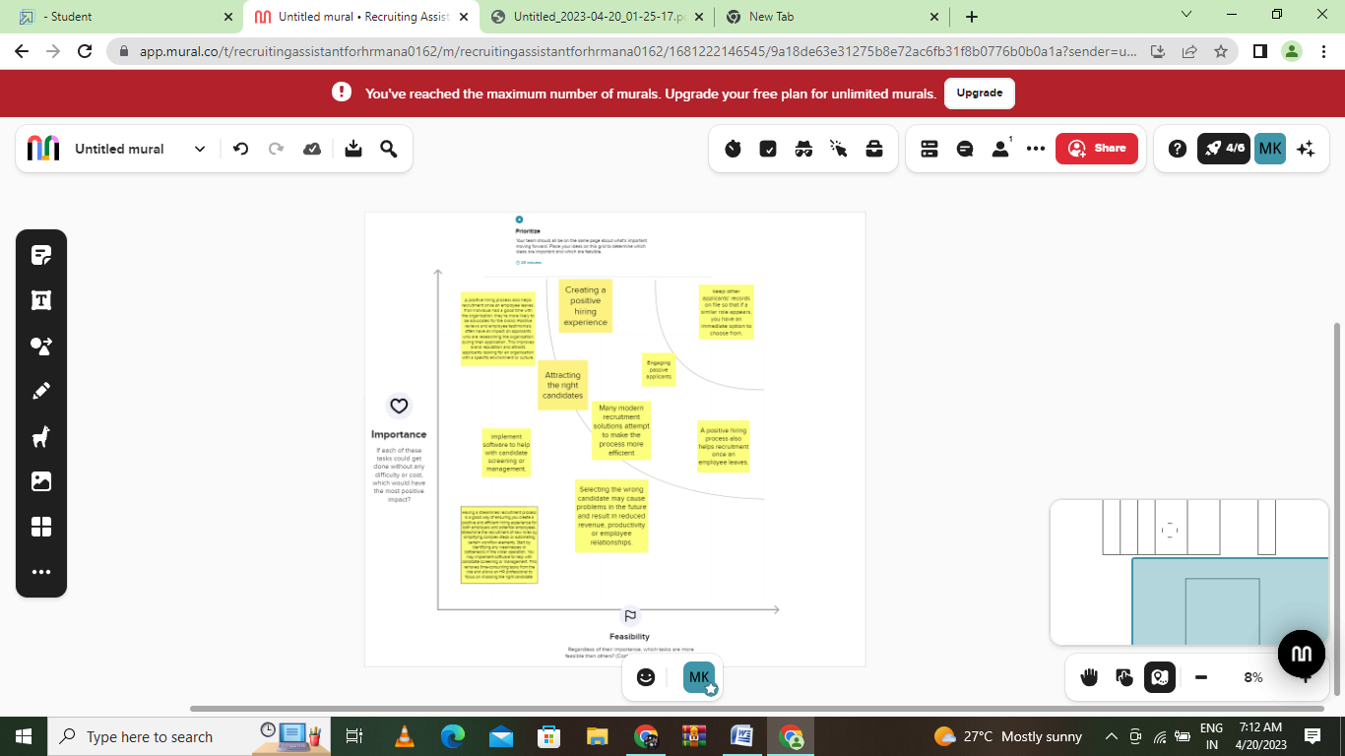

1. RESULT
   1. **Data Mode:**

|  |  |  |
| --- | --- | --- |
| **OBJECT NAME** | **FIELD IN THE OBJECT** | |
| Job Posting Site | **Field lable** | **Data type** |
| Job Posting site URL | URL(255) |
| Status | URL(255) |
| Technical | URL(255) |
| Description | URL(255) |
|  |  |  |

* 1. **Activity and Screenshot**

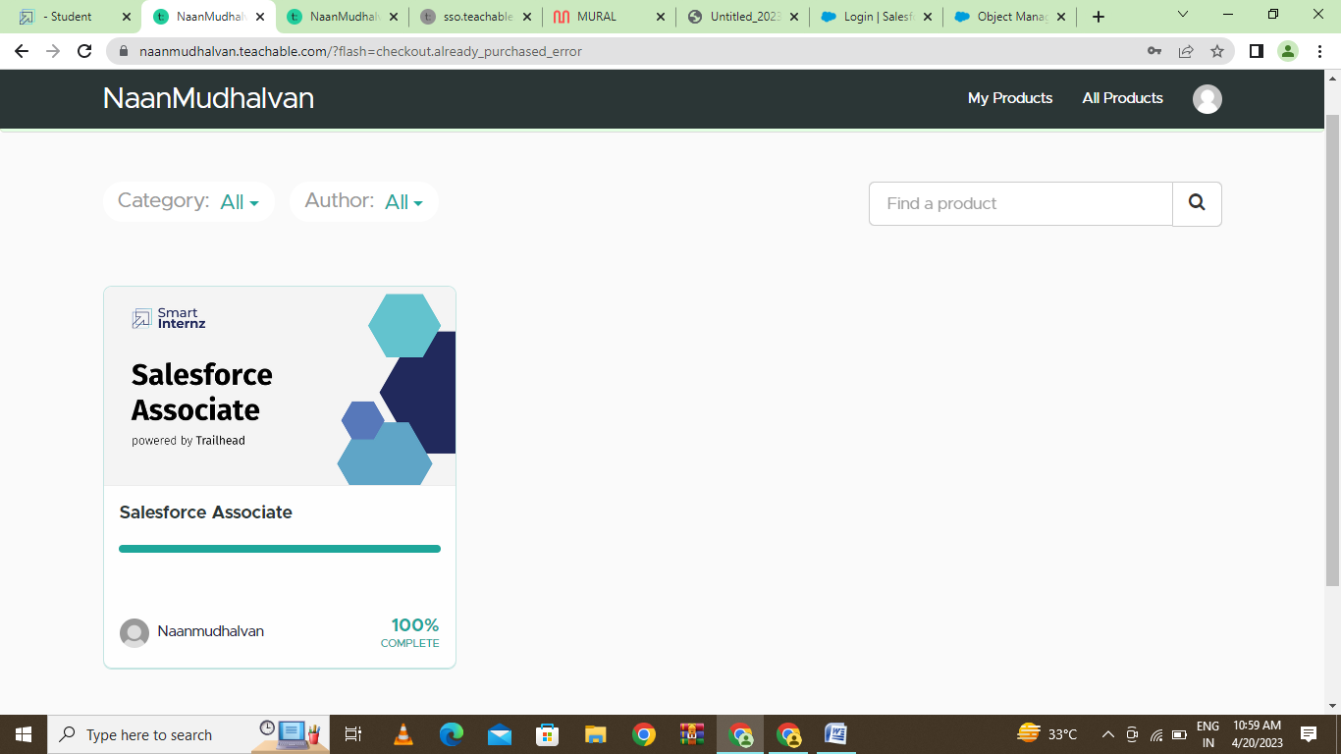

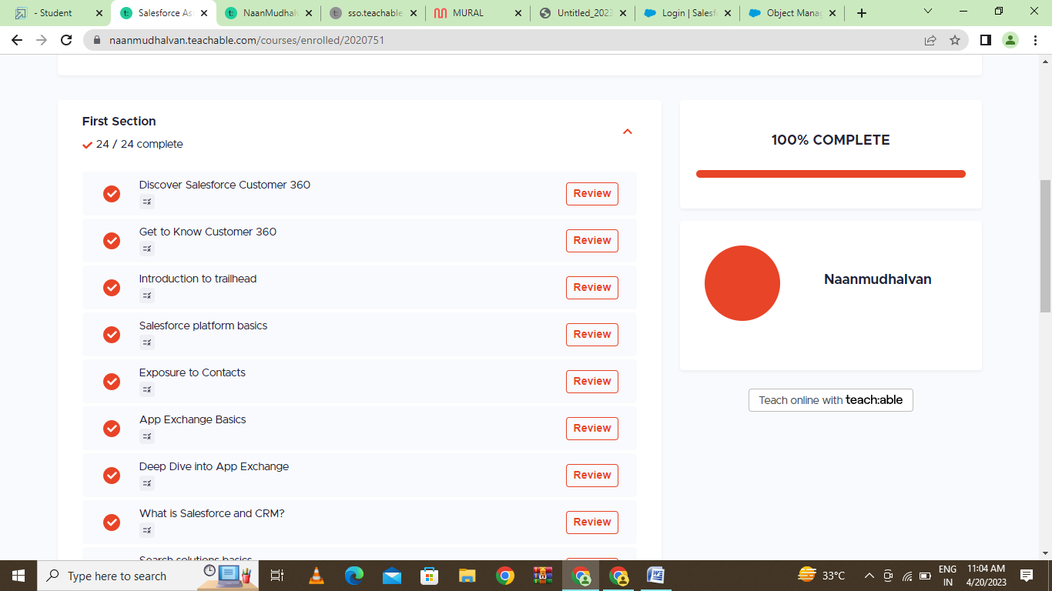

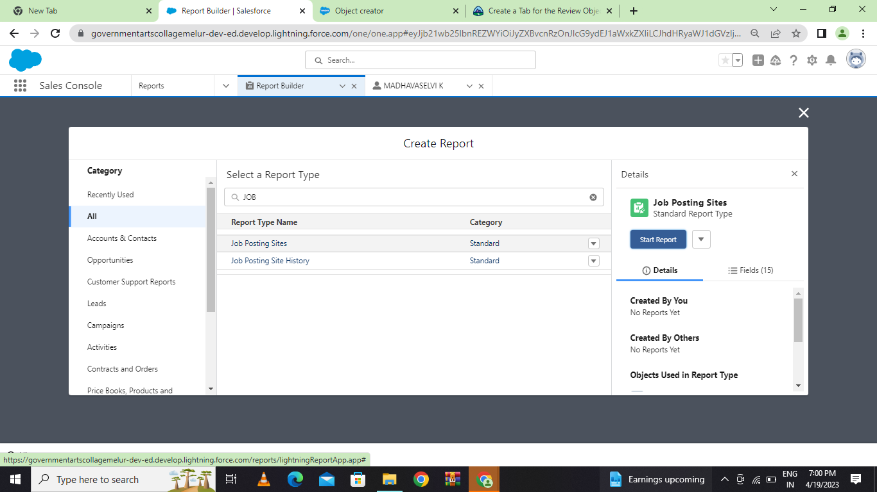

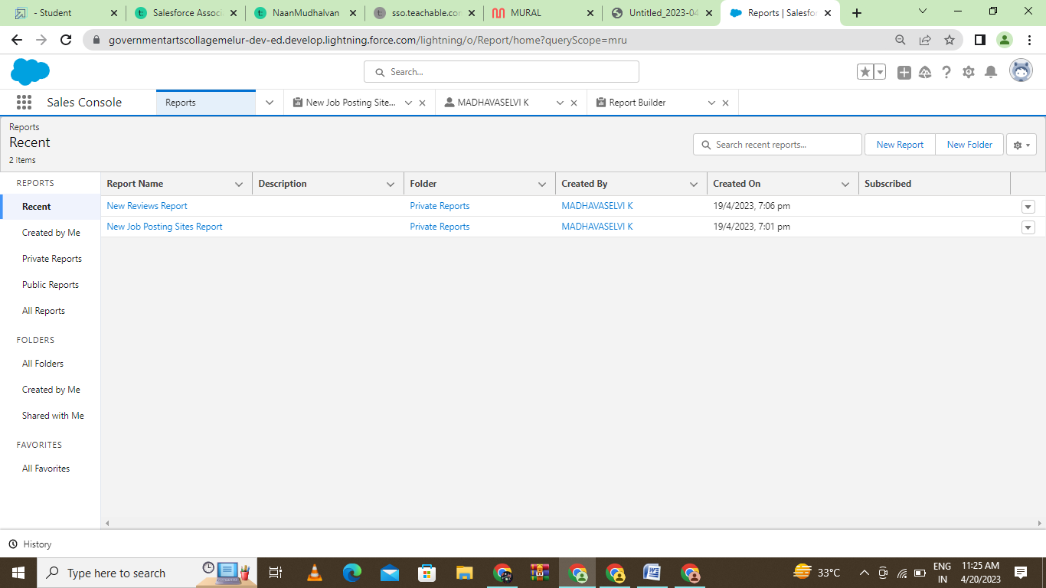

1. Trailhead Profile & Public

Team Lead : https://trailblazer.me/id/mlkselvi

Team Member 1 : https://trailblazer.me/id/kvalli15

Team Member 2 : <https://trailblazer.me/id/mpandi70>

Team Member 3 : https://trailblazer.me/id/vijap24

1. ADVANTAGES & DISADVANTAGE

Advantages

* You can develop your skills.
* You have various opportunities for employment.
* You can make meaningful contributions to organization.
* You can decide whether you want to pursue a career in HR
* You may help develop other staff members
* You can collaborate with other professionals

Disadvantage

* The workload is huge
* Stressful job
* Handling the problems of various people
* A need of experience

1. APPLICATIONS

* In addition to hiring
* Training and terminating employees
* An HR department is responsible for performing administrative tasks
* Creating a company culture
* Writing an employee handbook
* Facilitating employee benefit
* Managing payroll and taxes
* Maintaining legal risk and compliance measures with federal
* State and industry regulations.

1. CONCLUSION

Here, I have come to the end of the project on the topic Recruiting assistant for HR manager structure.I tried my best to include all the necessary points that are required related to the given topic.

1. FUTURE SCOPE

Human Resource Planning refers to a process by which the **company tries to find the number of jobs vacancy** in which a particular department and The number of staff required with the necessary qualification and experience.

Human Resource Planning refers to a process by which the **company tries to find the number of jobs vacancy** in which a particular department and The number of staff required with the necessary qualification and experience. Human Resource Planning refers to a process by which the **company tries to find the number of jobs vacancy** in which a particular department and The number of staff required with the necessary qualification and experience.